

Yizkor MEMORIAL BOOK
YOM KIPPUR
10 Tishri 5787 September 21 , 2026

5786 YIZKOR 2025

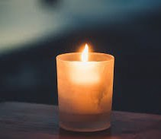

Yizkor (“Remember”) is the memorial service that is recited on Yom Kippur and other major Jewish festivals. It is especially appropriate for Yom Kippur because this is the day on which we enact our own deaths – wearing white like the traditional burial shroud, refraining from life- affirming activities like eating and drinking – so we can better reflect on the meaning of our lives. The boundary between the living and the dead seems thinner today. As we contemplate our lives and our mortality, we remember those who have gone before us: those who helped us become the people we are, those whom we miss and cherish every day, those whom we strive to honor through our deeds today and all days.

Zichronam livrachah – May our loved ones’ memories be an abiding blessing.

We remember with love and reverence our departed whose names have been inscribed in this Memorial Book.

Remembered by

Susan Amouroux

Ann Anderson

Bud Amouroux Dorothy Golding
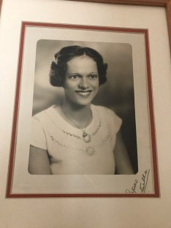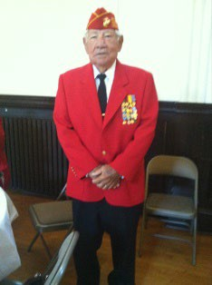

Arthur C. Anderson Ida E. Anderson Robert C. Creelman Rose M. Creelman Doris C. Creelman Leslie R. Creelman Macedonio Ayala Florine Van de Cappele
Jerry J. Swartz Joanne “Candi” Hageman

Jackie Bazley

Karen and Ted Bresler

Bennett S. Scott Fredrick Bazley
Albert Brodzinsky Richard Brodzinsky
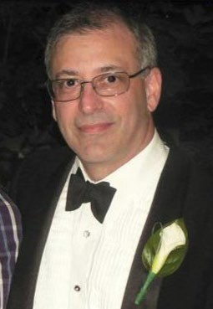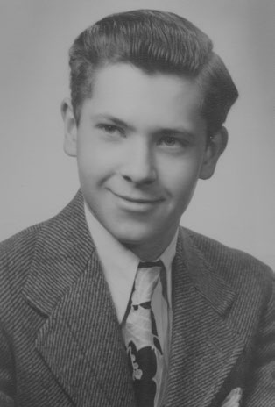

Sidy Bresler Harry Bresler Fanny Bresler Max Bresler Sara Lewis Elliot Lewis David Metz Jennie Metz Israel Schoenfeld
Tauba Schoenfeld

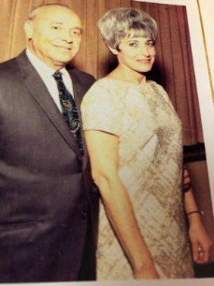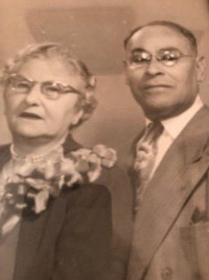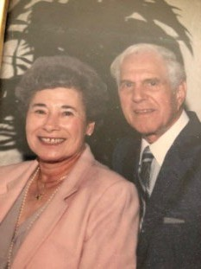

Janine Charlton

Dr. Judith Gray Holcomb
Gail Epstein Steve Charlton Morris Sherman
Ellen Rosen

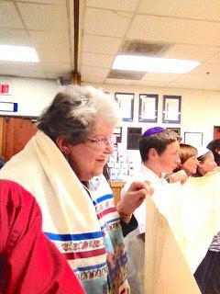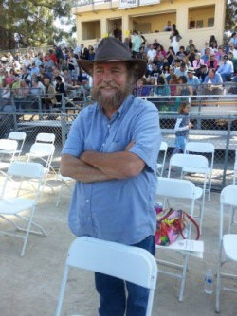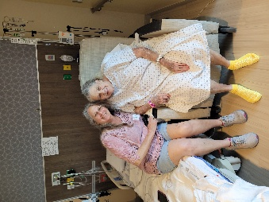

Cheryl Cohen

Blanche Cohen Lester Cohen Bernard Katz Florence Barg Aneta Katz Hyman Katz
Phyliss Katz
James Cohen Ida Cohen Minnie Klein Jack Klein

Beth Ehrlich and Ken Smith

Sherry Ehrlich Lines
David Blumenthal Dolores Speed
Les Speed Ruth Ehrlich Philip Ehrlich Robert W. Smith Louise J. Smith Bessie Feldstein Morris Feldstein Rose Ehrlich Max Ehrlich Roger Weissberg

Michelle and Alan Eisenbruck

Gertrude Eisenbruck Jerome Eisenbruck Abraham Hertzberg Bella Hertzberg

Janice and Rick Fonteno

Moishe (Murray) Klein
Jordana Aliza Michael Klein Ricky Gold Rena Fonteno Oscar Fonteno
Oscar Fonteno, Jr.

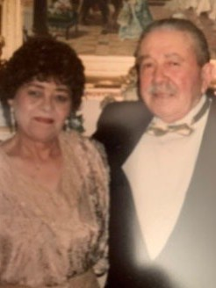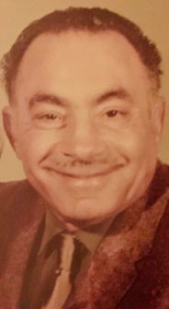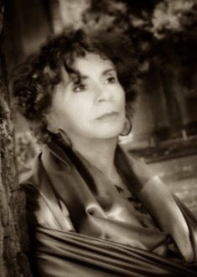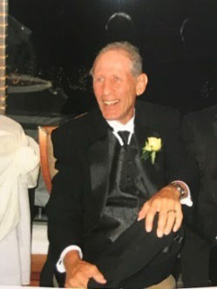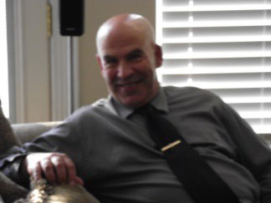
Terri Gladish
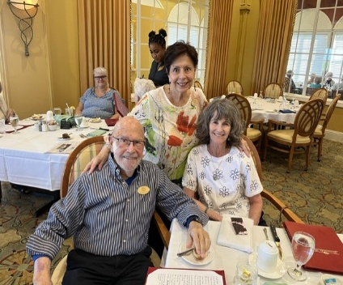
Renee Bodker Jerome Salzman Madeleine Salzman
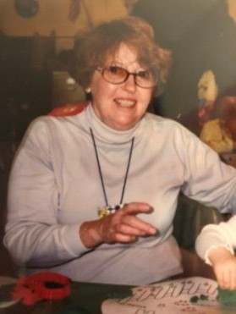
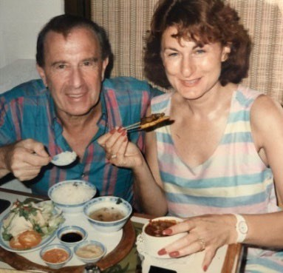
Mort Sinkoff

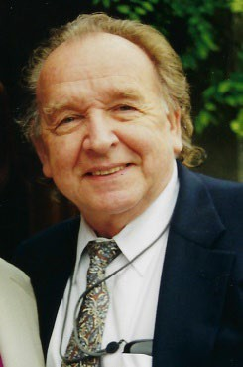
Verrona Gore and Steve Barncord

Rose DeJack Mattison Gore Harriett Gore
Jay Gore Gerald “Jay” Barncord Mona Barncord
Robin Barncord Clapp
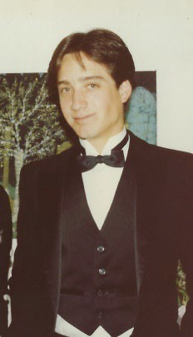
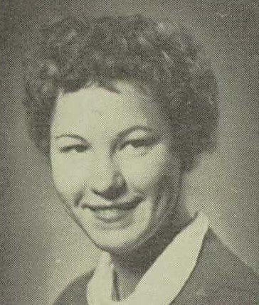
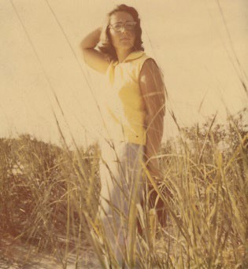
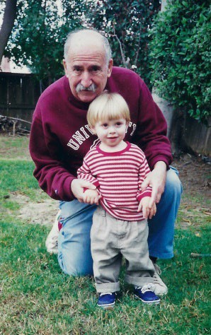
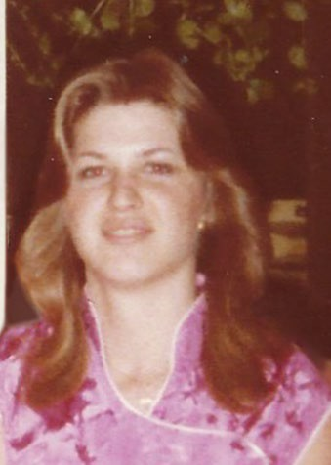
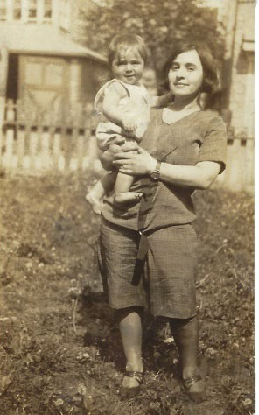

Stanley Keiser & Family

Jonathan King

Larisa Krasnovsky

Danette Keiser
Sylas Keiser Sadie Keiser Michael Keiser Dan Borelli Hazel Borelli Daniel Borelli


Sherry King

Shayvah Kleynerman Leib Kleynerman Rita Krasnovskaya Abram Krasnovsky Riva Senderovich Zisya Sherman

Norma Lipman
Frederic Lipman

Dave Makower
Esther Rose Makower
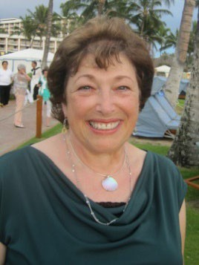

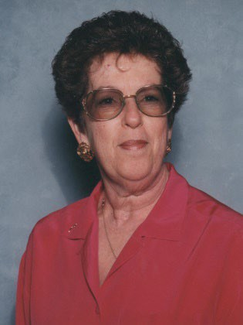
Sam and Debi Mishael and Jack Swedelson

Jackie and Art Naftaly

Roberta (Bobbi) Swedelson

Stanley Naftaly Jeanette Naftaly Richard Naftaly Phillip Naftaly Betty Naftaly Jack Lusher Gella Lusher

Arlynn Bitter Peavey, and Family

John Peavey Ben Fishman Anna Fishman
William ‘Bill’ Bitter
Carol Bitter Eric Bitter Luelle Bowman Claud Bowman
Mary Thomas Brooks Joyce Lindstrom

Stewart and Audrey Perlman

Ronnie and Jim Petersohn

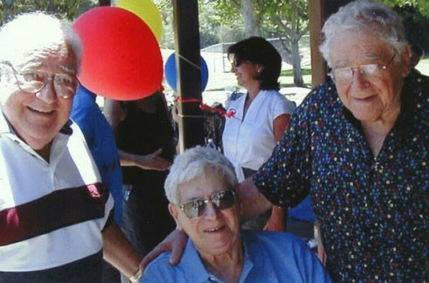
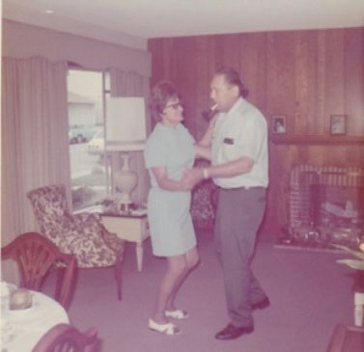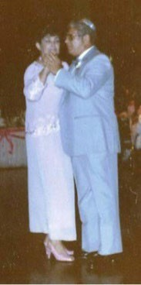

Esther Friedman
Mitchel Friedman
Aubrey Perlman
Barry Perlman
Grace Perlman

Ethel Veis Sam Veis
Lawrence Weitzman Pauline Weitzman
Arlane Veis Marian Veis Ernest Veis Norman Veis
Lily Veis William Veis George Petersohn Rita Petersohn

Sonja Radcliff

Walter and Margarita Kopilow
Danny Radcliff

Laurie and Greg Ravenscroft

Bernard Fisher
Wendy Otelsburg
Alan Ravenscroft
Shirley Ravenscroft
Steven Ravenscroft

Betty Rogoff

Barry A. Rogoff Joseph H. Elefant Rose Elefant Ralph Elefant Louis Elefant Aaron C. Rogoff Betty K. Rogoff Jack Elfant
Jean Matusewitch
Herb Elfant William Cohen Frank Cohen Stuart Elefant Benjamin Crawford

Herman Rosenbaum

Rosalie Rosenbaum
Edwin Malitz Beckie Perlman Frances Perlman Louis A. Rosenbaum Anna Rosenbaum Manuel Malitz Helen Malitz Harvey Schack
Ruth Schack
Boris Putterman

Rick and Sharon Sacks

Hilda Zell Martin Zell Dora Brand Howard Brand Phillip Brand
Dr. Leonard Z. Sacks
Frances Sacks Dr. Leo Kaplan Marjorie Kaplan
Chell Zell Sarah Zell Sidney Charney Rudi Charney Sharon Hastings

Jack Samosky

Howard Moeckler Herman Samosky Lena Samosky Marvin Samosky
Marilyn Mason Rotter Judy Plotkin Schuster
Hershel Rotter Barbara Berkowitz Marge Mishlove Donald Samosky

Rabbi Avi Schulman & Rabbi Eve Ben-Ora

Birdie Schulman Arnold Schulman Dr. Avi Ben-Ora Marcia Ben-Ora

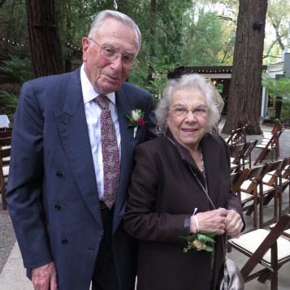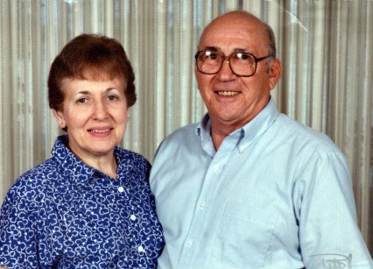

Susan & Sheldon Schwartz

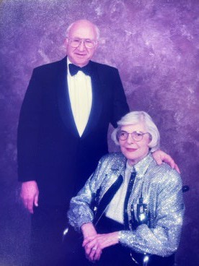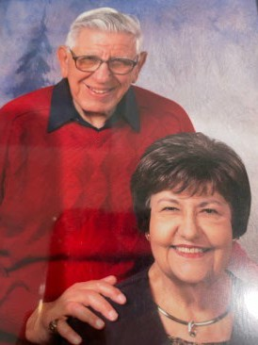

Mara Sheade

Cynthia F. & Edward J. Schwartz Reva B. & David M. Chapman Sheldon Jules Zimmerman Norris E. Chapman
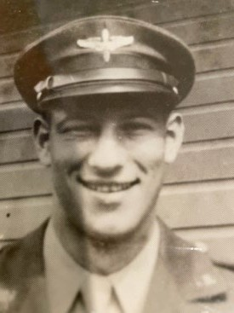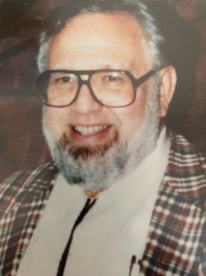

Alan Teitel Eileen Teitel Murray Teitel
Ruth Hill

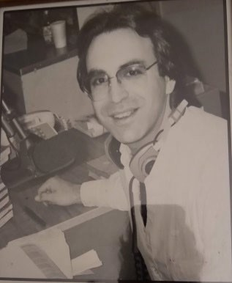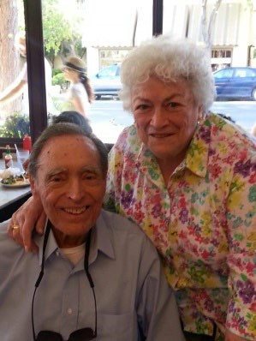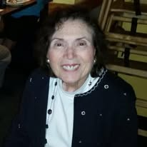

Shana & Hugo Silverberg-Rajna

Judy Friend Silverberg
Jussi Rajna

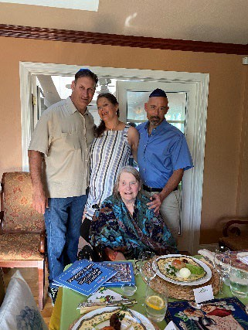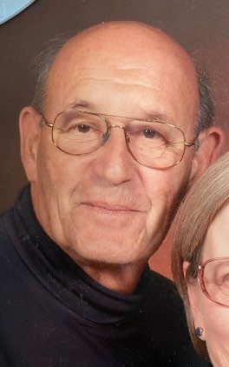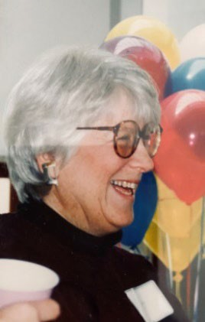

Jennifer van Stelle

Carl van Stelle Celeste Jaqueline van Swieten-van Duyne

Leslie and Dan Strauss
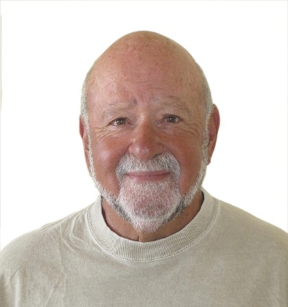
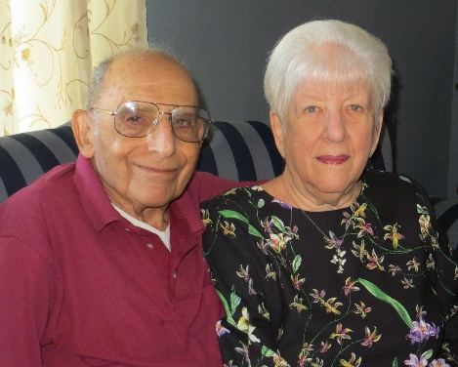
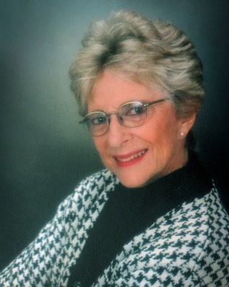
Paul Gerhardt, Toby Lila Gerhardt, Harlene and Marty Strauss

Dalia Vernikovsky
Jan Armstrong

Phoebe and Alan Weiner

Judy L. Clark Ann Weiner Samuel N. Weiner Bernard Biederman Miriam Biederman Vera Woolbert Richard Woolbert Ann-Helen Leff

Phyllis and Roger Wood

Shirley Lerch Leon Lerch Alice Rosenstein
Benjamin Rosenstein
Rose Lerch Simon Lerch Herman Lerch Ethel Cohen

Marla Zarrow and Family



Jill and Pip Ziman

Phyllis R. & Herbert G. Zarrow Daisy (Abrash) & Reuben Roemer Rose (Mishkin) & Harry Zarrow
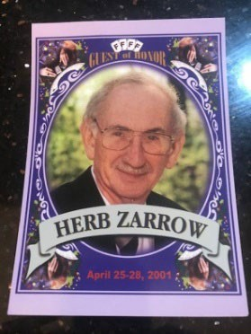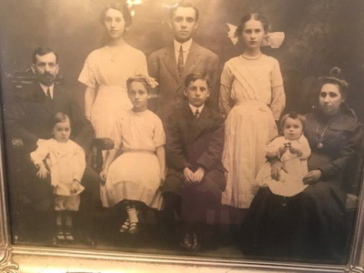

Roberto Mendez Linda Mendez

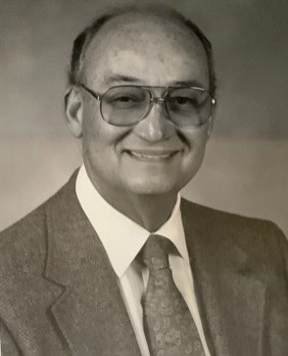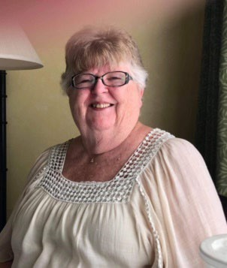

All of us

The Jews of Pacov, Czechoslovakia, whose Holocaust Torah is in our Ark

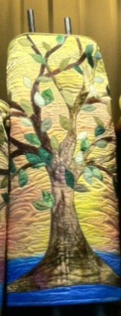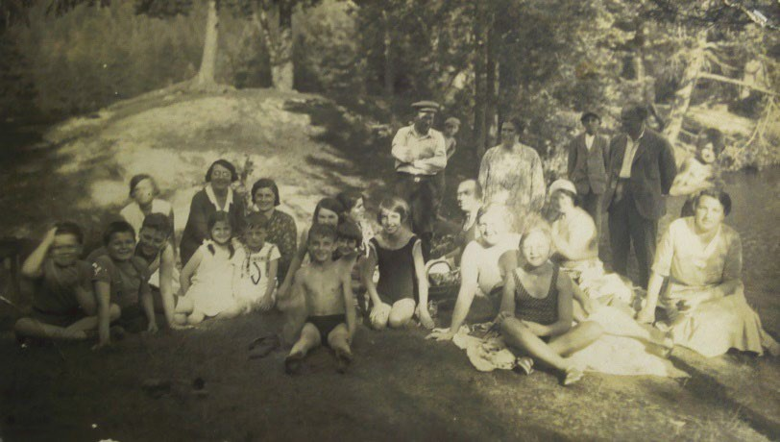

MOURNER’S KADDISH

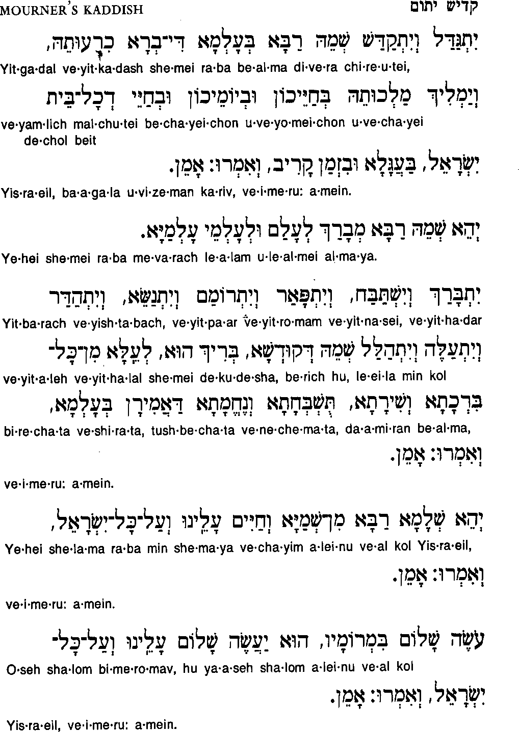

Let the glory of God be extolled, let the great Name be hallowed, in the world whose creation God willed. May God’s reign soon prevail, in our own day, our own lives, and the life of all Israel, and let us say, Amen.

Let God’s great name be blessed forever and ever.

Let the name of the Blessed Holy One be glorified, exalted, and honored, though God is beyond all the praises, songs, and adorations that we can utter, and let us say, Amen.

For us and for all Israel, may the blessing of peace and the promise of life come true, and let us say, Amen.

May the One who causes peace to reign in the high heavens, let peace descend on us, on all Israel, and on all the world, and let us say, Amen.

* *

May the Source of Peace send peace to all who mourn, and comfort to all who are bereaved. Amen.

